# Mapping Ethical Axioms to Ψ-Inferential Ontology

This document presents a conceptual alignment between a set of ethical axioms and the principles of ψ-inferential interpretations of quantum mechanics. It illustrates how an epistemically humble stance toward reality—embedded in ψ-inferential frameworks—naturally aligns with an ethical system grounded in inference, uncertainty, and relational respect.

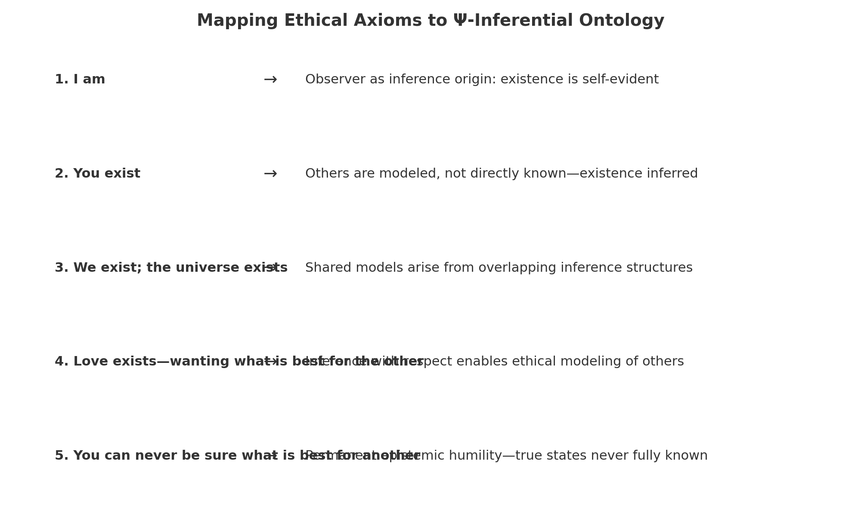

## Detailed Mapping

### 1. I am

Observer as inference origin: existence is self-evident

### 2. You exist

Others are modeled, not directly known—existence inferred

### 3. We exist; the universe exists

Shared models arise from overlapping inference structures

### 4. Love exists—wanting what is best for the other

Inference with respect enables ethical modeling of others

### 5. You can never be sure what is best for another

Permanent epistemic humility—true states never fully known